Acute Psychiatric Inpatient Observation System

System Requirements Specification

Prepared By:
CAS757 Group 6

Document Owner: Group 6
Version Level: 1.0
© Copyright CAS757 Group6. 2014 All Rights Reserved
Table of Contents
1 Introduction 1
1.1 Scope 1
1.2 System Summary 1
1.3 Project Deliveries 1
1.4 Revision History 2
1.5 Stakeholder Approvers 2
1.6 Reviewers 2
1.7 System Objectives / Overview 2
1.8 Acute Psychiatric Inpatient Observation System Definitions 4
2 References 5
2.1 Customer Documents 5
2.2 Non-Customer Documents 5
2.3 Updating this Specification 5
3 Requirements 6
3.1 Functional Requirements 6
3.1.1 Functional Requirement 1 – login user 6
3.1.2 Functional Requirement 2 – create user 7
3.1.3 Functional Requirement 3 – modify user 8
3.1.4 Functional Requirement 4 – delete user 8
3.1.5 Functional Requirement 5 – create new patient 9
3.1.6 Functional Requirement 5 – add patient record 9
3.1.7 Functional Requirement 6 – view patient history 9
3.2 Usability Requirements 10
3.2.1 Usability Requirement 1 - navigation 10
3.2.2 Usability Requirement 2 - display 10
3.2.3 Usability Requirement 3 - human factors 10
3.2.4 Usability Requirement 4 – User performance 10
3.3 Non-Function Requirements 10
4 Acceptance Criteria 12
4.1 Login User 12
4.2 Create User 12
4.3 Delete User 12
4.4 Update User 12

Introduction

Scope
This specification establishes the requirements for the Online Course Management project.
Electronic Health Records have been shown to be beneficial to many areas of clinical medicine, however each field has its own unique requirements and potential benefits regarding EHRs [7]. Many mental health facilities have held off on high level EHR adoption due to current systems failing to meet these unique requirements (which are discussed in the next section) [4]. The motivation behind this product is not only to increase applicability and therefore the use of electronic health records in psychiatric medicine, but to harness the benefits of EHR’s specific to the mental health field.
The scope of this project is the design of an application and accompanying graphical user interface to input data for mental health patients in acute care. This will be a tool to work along with existing electronic health records systems. The intended use of the final application will be for ongoing regular monitoring of the well-being of acute mental health patients. The tool will be specialized for the needs of both nurses and doctors working in the mental health fields. More specifically, the user interface will be consistent with the usability needs of psychiatric nurses while the data collection will be determined by the diagnostic needs of psychiatric clinicians.

System Summary
Tracking and monitoring patients in an acute mental health setting is a routine task for mental health nurses [2]. Nurses must collect ongoing data on the physical, developmental, cognitive and mental status of all the patients being treated through monitoring things like daily activities, personal hygiene and functional health status [1]. This information must be documented in a retrievable format such as an electronic health record [1]. However, there are specific needs of nurses in an acute mental health ward which makes this project unique which include portability and ability to monitor multiple patients at once. This project will encompass the user analysis and design of a data entry tool for tracking patients within an acute mental health setting. The tool will be compatible with existing electronic health records systems and will run on a portable platform (such as a tablet computer). The goal is to streamline existing systems to make it more user-friendly and add new functionality to increase ease of use. Evaluation of the tool will be done based on the user requirements of mental health nurses.

Project Deliveries
There are several unique features of mental health care that must be considered when designing EHR for mental health. Patients remain in the care of a specialist for a long period of time (months or years) so resulting records could be very lengthy or have details of many patient-carer encounters [4]. In addition to many entries, due the long and unstructured (compared to other medical fields) consultations, clinician notes tend to be long and narrative in nature [4], [6]. Additionally, there are concerns over the security of EHR due to the sensitivity of mental health data leading to the potential for stigma and discrimination based on the information [3], [4]. In acute mental health facilities nurses are required to continually monitor the well-being of the patients [2]. Nurses must collect ongoing data on the physical, developmental, cognitive and mental status of all the patients being treated through monitoring things such as daily activities, personal hygiene and functional health status [1]. This information must be documented in a retrievable format so that it is available to the doctor for review [1]. This process is distinct from clinician notes in that entries are made often and consist of succinct observations of patients. Many EHR systems currently available lack the features required for nurses to complete these tasks or the functionality to use this data as meaningful information for the clinician.
The proposed solution is a data entry application on a portable platform with data storage on an external database. The format of all data collected will be structured so as to be compatible with existing electronic health records. The structure of the data is important for the ability to convert data into graphics for quick and meaningful use by physicians. The actual display of patient information in a graphical format for efficient interpretation by physicians is not included in the scope of this project. Interfaces for data collection must be user-friendly and accommodate the needs of psychiatric nurses using the system. These needs include using the application to track multiple patients, simple to switch between patients and reminders for checking on patients based on a set schedule. Finally, the application must have user verification in order to protect the confidentiality of the patients.

Revision History
All suggestions, comments, and requests for changes to this document should be directed to the document owner.
Date of Revision | Section Revised | Nature of Revision
03/10/14 |  | Initial Release

Stakeholder Approvers
The following are the Stakeholder Approvers of this Systems Requirement Specification (SRS).

Stakeholder Approvers | Representing Area | Date Approved
 | < Stakeholder 1>
 | < Stakeholder 2>
 | < Stakeholder 3>
 | ...
 | < Stakeholder n>

Reviewers
Reviewers | Representing Area
< Reviewer 1>
< Reviewer 2>
< Reviewer 3>
...
< Reviewer n>

System Objectives / Overview

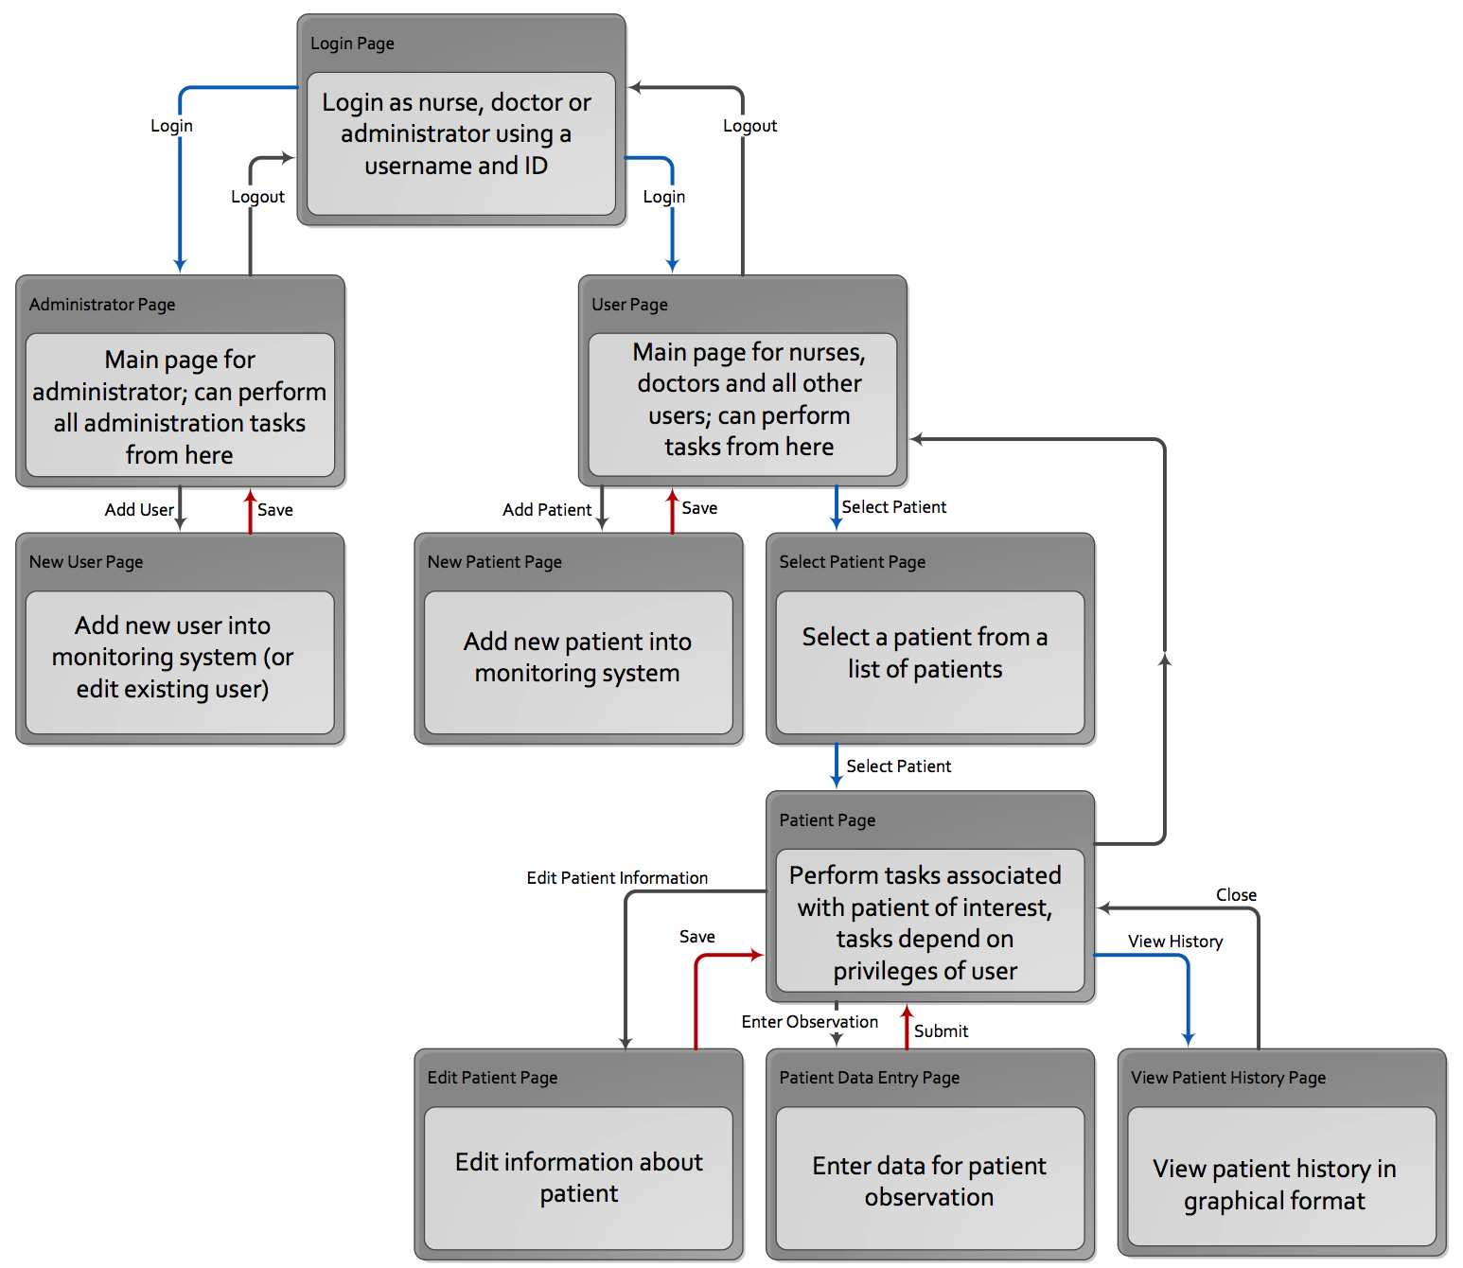

Figure 1 - System Context Diagram
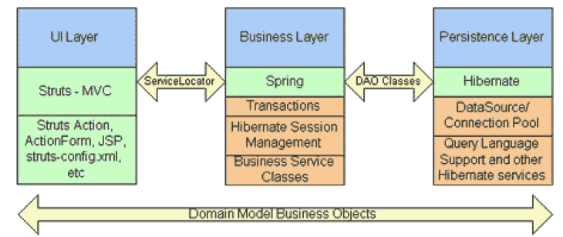

Figure 2 - Architectural Overview Diagram

Acute Psychiatric Inpatient Observation System Definitions
Term | Definition
Table 1 - Definitions

References

Customer Documents
Document Number / Location / Links | Reference Description/Name
 | Use-Case Specification 1.doc
 | Use-Case Specification 2.doc
 | Use-Case Specification 3.doc
 | Use-Case Specification 4.doc

Non-Customer Documents
Document Number / Location / URL | Reference Description/Name

Updating this Specification
This document will be put under formal change control by the Group6 project team after stakeholder approvers’ sign off this document.

Requirements

Functional Requirements

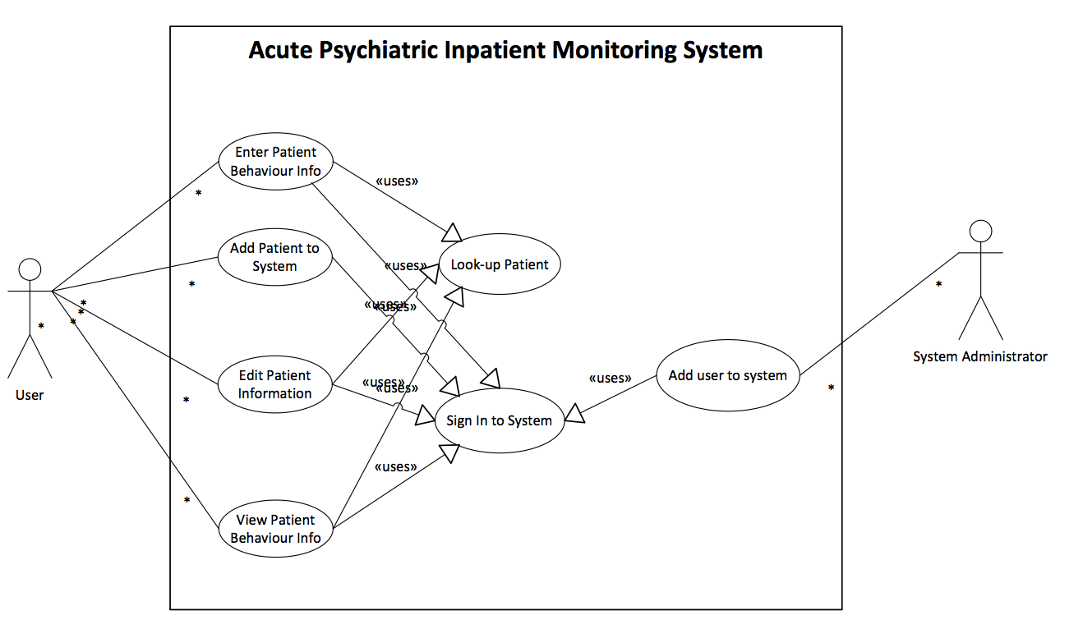

Figure 3 System Use Case Model

Functional Requirement 1 – login user
Users are authenticated before any access to patient information is allowed.
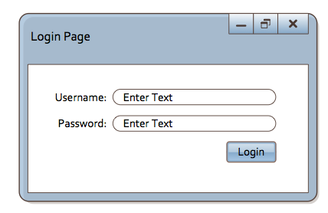
[Descriptions]. The following table describes the detailed case:
Login | What it means | Comments
Table 2 login criteria
[Some other descriptions]

Functional Requirement 2 – create user
Administrators can create user accounts for nurses, doctors and other administrators.
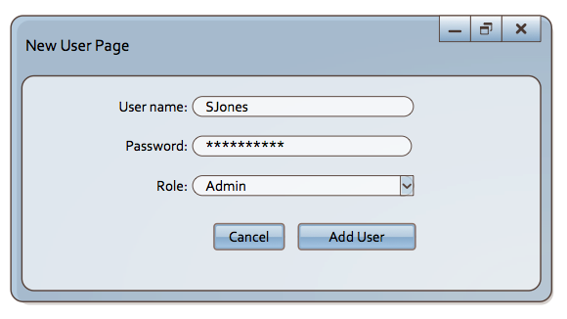

Attribute | Type | Size | Null | Duplicate
Table 3 Attribute Constraints
[Some descriptions.] The validation covers the following cases:
- Constrains 1
- Constrains 2
- Constrains 3

Functional Requirement 3 – modify user
Administrator can edit user information.
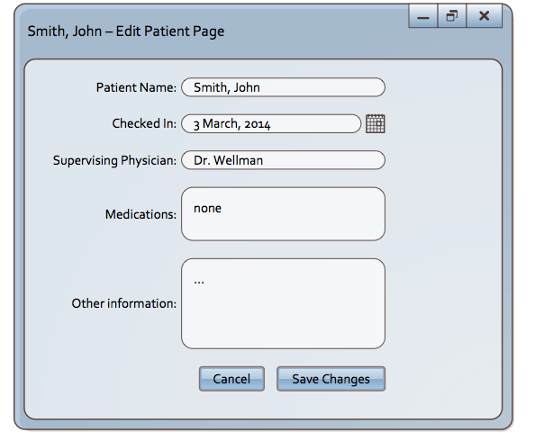
Some descriptions. The validation covers the following cases:
- Constrains 1
- Constrains 2
- Constrains 3

Functional Requirement 4 – delete user
Administrator can search for and delete users from the system.
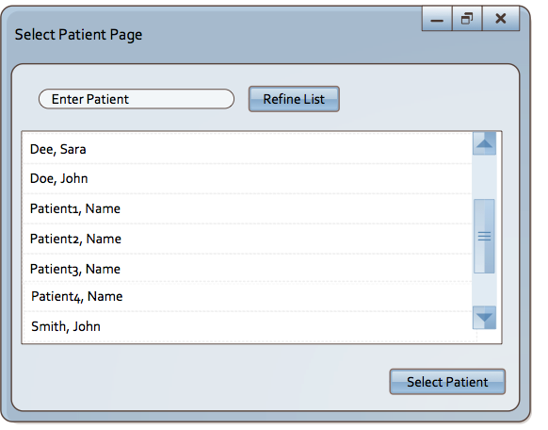

Functional Requirement 5 – create new patient
Administrators can create new patient in the system.
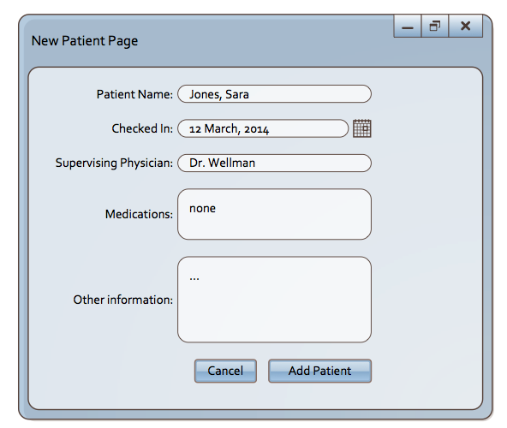

Functional Requirement 5 – add patient record
Nurses can add a patient behavior record to the patients full history.
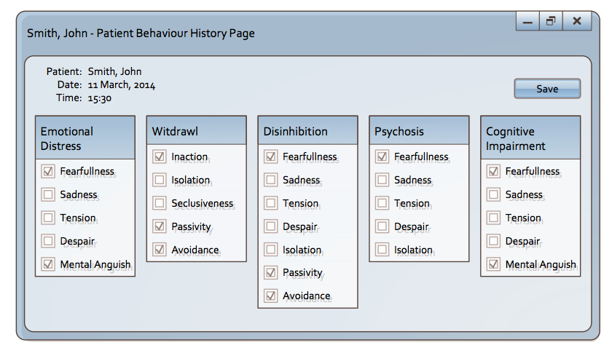

Functional Requirement 6 – view patient history
Doctors and nurses can view patient history graphically.
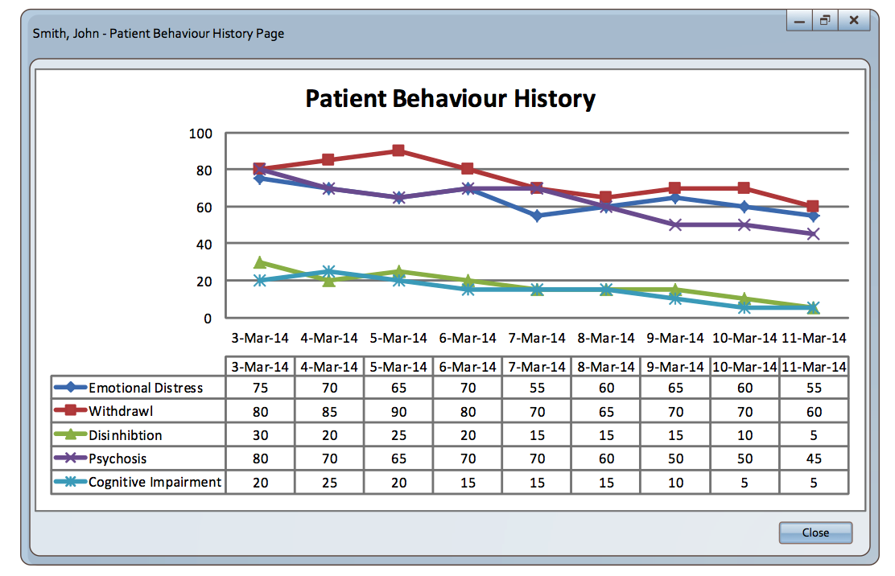

Usability Requirements

Usability Requirement 1 - navigation

Usability Requirement 2 - display

Usability Requirement 3 - human factors

Usability Requirement 4 – User performance

Non-Function Requirements
Performance (including Capacity)
The response time is limited to less than 1 second for all functional operation including searching course, inserting course, modifying course and deleting course. For reporting courses, it is limited to 2 seconds.
Scalability
When the number of users increases to more than one hundred, the database needs to be migrated from current embedded local database to larger RDMBS. If numbers increase larger, WebSphere AppServer may be clustered.
Availability (including Recoverability and Reliability)
24 X 7 availability
Maintainability (including Flexibility and Portability)
If the number of users increases to more than one hundred, the database needs to be migrated from current embedded local database to larger RDBMS (db2, oracle etc). The application codes shall not need to be modified except to create database scheme in RDBMS.

Acceptance Criteria

4.1 Login User

4.2 Create User

4.3 Delete User

4.4 Update User

